Provide a screenshot to show that you have successfully downloaded and extracted the johntango Streaming GitHub repository on your local machine.

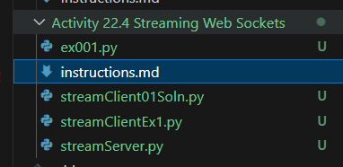

Provide a screenshot to show that you successfully opened the streamServer.py file in VS Code.

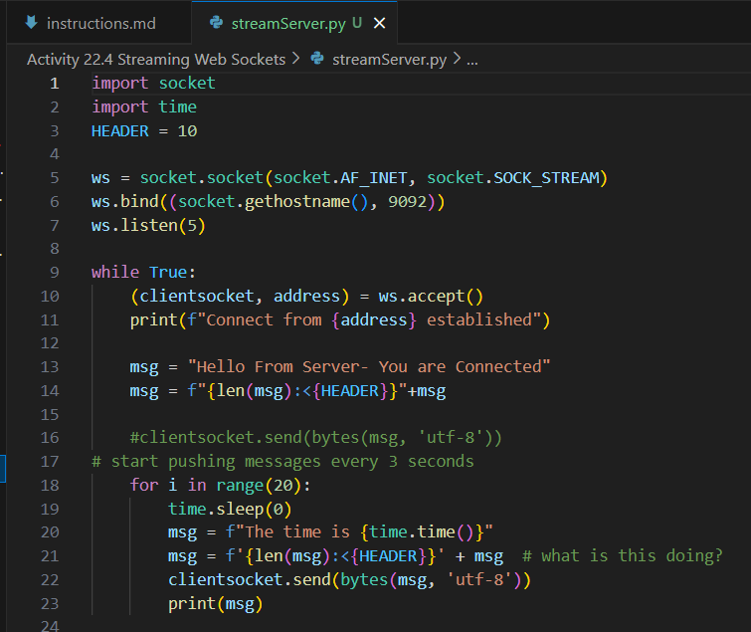

Provide a screenshot to show that you successfully opened the command prompt in the streamServer.py folder and ran the python streamServer.py command without errors.



Provide a screenshot to show that you successfully opened the command prompt in the streamClientEx1.py folder, ran the python streamClientEx1.py command, and received the message from the server.

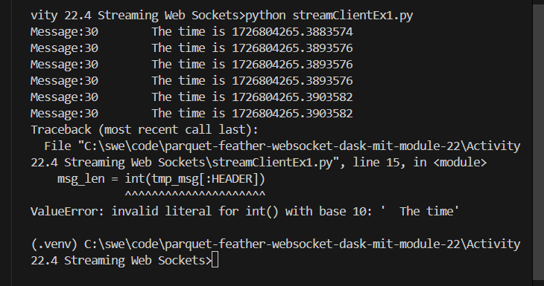

Provide a screenshot to show that after running the client code, you can view the sent messages output over the server command line interface.

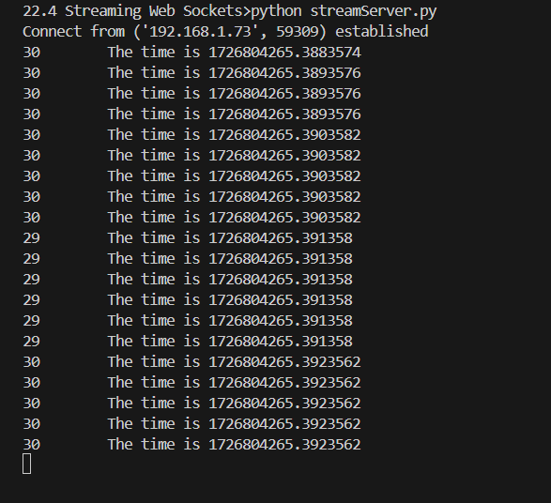

Provide a screenshot to show that you successfully opened the command prompt in the streamClient01Soln.py file, ran the python streamClient01Soln.py command, and can view the received message from the server.

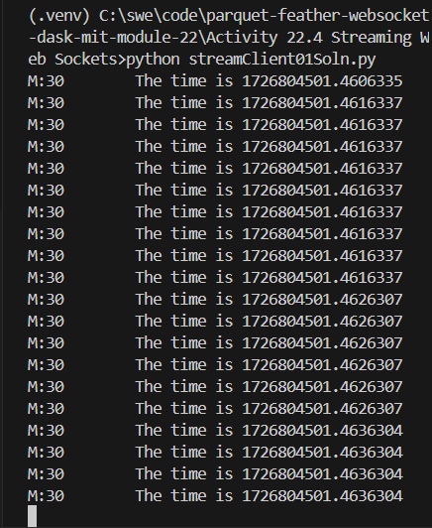

Provide a screenshot to show that you successfully opened the client code in the streamClient01Soln.py folder and added a debugging checkpoint at line 13.

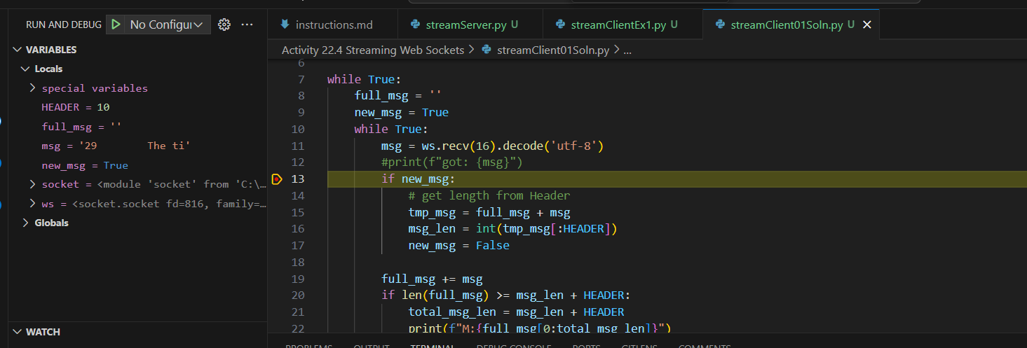

Provide a screenshot to show that you were able to run the client code in debugging mode and see that the value of the Python msg variable is “'29 The ti'” in VS Code.

